**Image Processing(OpenCV Assignment)**

1. Image Preprocessing:

The algorithm starts by loading the input image and converting it to the HSV color space. This conversion helps in better isolating the blue background, as specified in the requirements. A mask is created to extract the blue background using a predefined HSV range for blue colors. Morphological operations (erosion and dilation) are then applied to the mask to remove small noise and smooth out the mask.

2. Segmentation and Counting:

The inverted mask is used to obtain the rice grains. This is done because the background is blue, and the rice grains are in contrast to this background. The mask is then converted to grayscale and thresholded to separate the rice grains from the background. Contours are found in the thresholded image to identify individual rice grains. The number of contours corresponds to the total number of rice grains in the image.

3. Grain Classification:

Each contour is analyzed to classify rice grains as either broken or full. This classification is based on the area of the contour. Rice grains with areas below a certain threshold are considered broken grains, while those with larger areas are considered full grains. This step assumes that broken grains have smaller areas compared to full grains.

**Visualizations of Results:**

The algorithm outputs the following for each test image:

•Total number of rice grains

•Total number of broken grains

•Total number of full grains

You can visualize the results by plotting these values for each test image. For instance, a bar chart or a pie chart can be used to represent the distribution of broken and full grains within the total rice grains count.

**Current Limitations:**

1.Thresholding Parameters: The algorithm relies on a fixed threshold value for differentiating broken and full grains. This might not be optimal for all images, especially if lighting conditions vary.

2.Area-Based Classification: The algorithm classifies grains solely based on their areas. This approach might not be accurate if there are variations in grain shapes and orientations.

3.Morphological Operations: The erosion and dilation operations are sensitive to noise. In some cases, these operations might remove small rice grains or introduce artifacts.

**Next Steps for Improvement:**

1.Adaptive Thresholding: Instead of a fixed threshold value, consider using adaptive thresholding techniques. These methods adjust the threshold value based on local image characteristics.

2.Shape Analysis: Incorporate shape analysis techniques to improve grain classification. Features like aspect ratio, circularity, and convexity can provide more accurate differentiation between broken and full grains.

3.Machine Learning: Train a machine learning model (e.g., convolutional neural network) to classify grains. This can learn complex patterns and relationships for accurate classification.

4.Noise Reduction: Experiment with advanced noise reduction techniques to improve the accuracy of grain segmentation.

5.Robust Background Detection: If the blue background isn't consistent, consider using more robust background subtraction methods.

6.Edge Detection: Utilize edge detection algorithms to enhance grain contours and improve classification accuracy.

7.User Interaction: Develop an interface where users can manually correct misclassifications, helping to fine-tune the algorithm.

8.Multi-Image Processing: Extend the algorithm to process multiple images in a batch, potentially using parallel processing to improve efficiency.

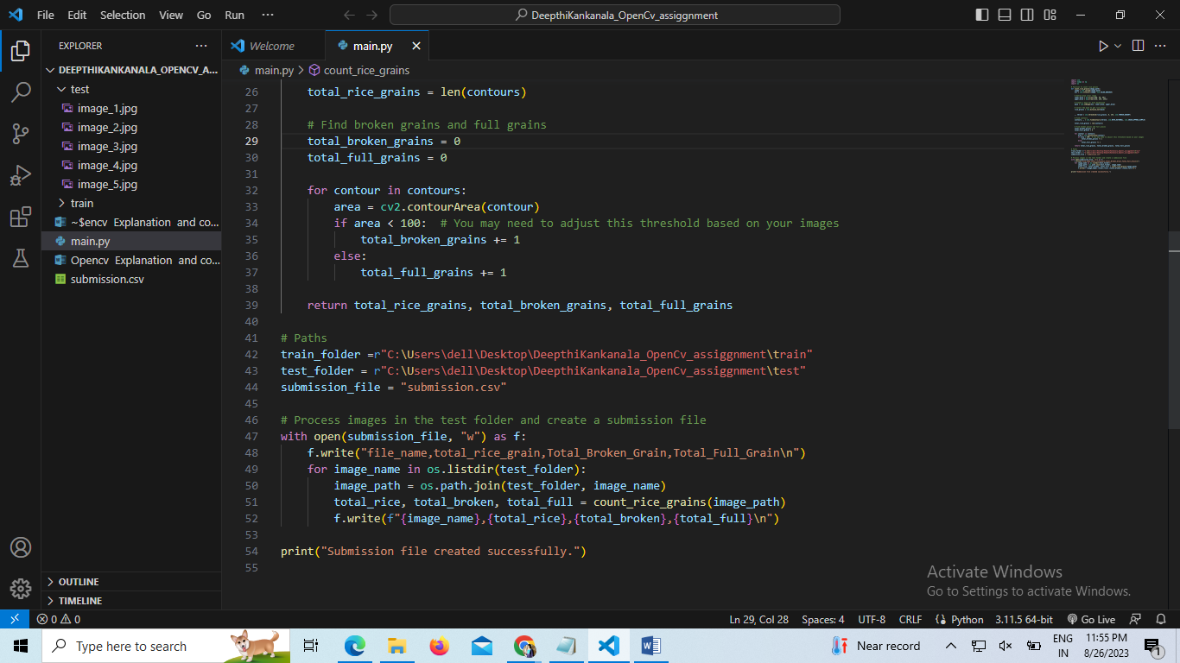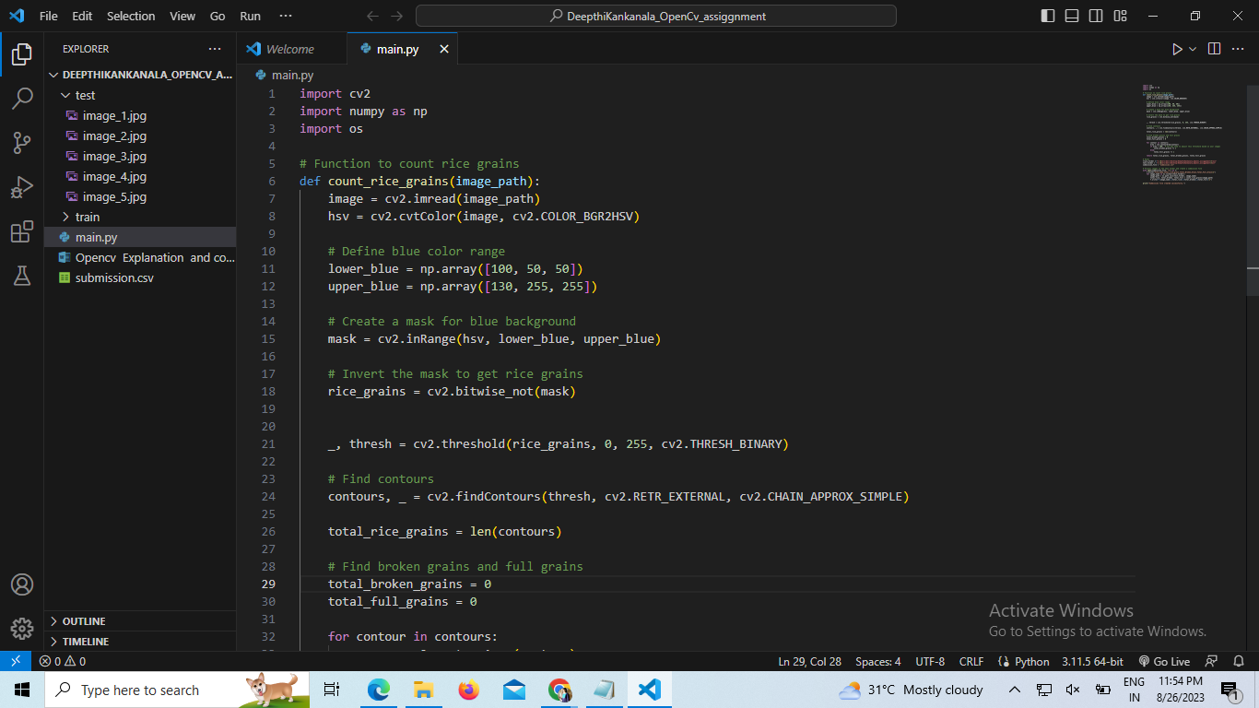

OUTPUT:

